**Computer Science 361 - Machine Learning**

Assignment 2 – Worth 5%

Due: 3rd of April, 2020.

**Title: How do Ensembles Work?**

**Data Set Order**

1. iris.arff

2. car.arff

3. balance-scale.arff

**Algorithms Order**

1. RandomForest

2. AdaBoostM1

3. Bagging

**Question1). Screen shot of two-tailed t-test of 3 runs from Weka “Analyse”**

**RandomForest classifier First**

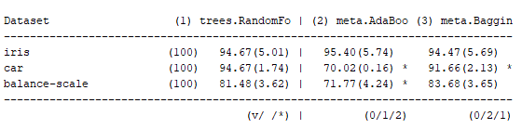

**AdaBoostM1 Classifier First**

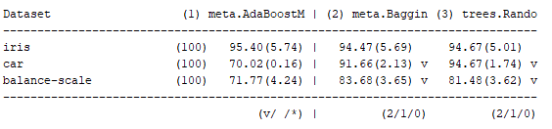

**Bagging Classifier First**

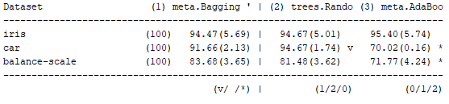

**Question2). A paragraph for each runs on which algorithm did best.**

**Iris Data Set**

For the Iris dataset, it seems like all algorithm returns similar outputs. However, RandomForest algorithm seems to show the best result for us to trust. Compared to Bagging, which RandomForest is a special case of Bagging, RandomForest resample attributes, not just instances. Iris dataset seems to show a better mean with less spread in data when attributes and instances are both resample within trees. Also, the iris dataset has characteristics where not much of error would occur when running the dataset. Therefore, Boosting algorithm would be the least best for Iris dataset.

**Car Data Set**

Similar to the Iris dataset, Car data set has a characteristics which contain attributes and instances where they are broadly distributed. Therefore, RandomForest algorithm which resamples both would show the best accurate result for the car data set.

**Balance-scale Data Set**

Bagging algorithm seems to show the best result for Balance-scale data set. It shows the closest mean with relatively low standard deviation. Also, as bagging algorithm only resample instances it seems to fit well with the characteristics of balance-scale as balance scale data showed instances as main data and errors were not necessary.

**Question3). Explain the difference in result and the significance of order in algorithms.**

The numerical value shown in each result table are identical but in different orders. However, the significant differences of classifier are different accordingly to the order of algorithms. The significant better or worse is identified by V, null or *. V clarifies that the result is significantly better than the main algorithm that is being compared to. * is the identification to significantly worse and null is the representative of no significant difference due to the broad overlapping results. Therefore, as numerical value of mean and standard deviation does not change by the order of algorithms, the better algorithm will remain better therefore the significant difference will change accordingly compared to the main algorithm.

**Question4). Which algorithm is reliable and why?**

From the given result, RandomForest is identified as most reliable as car and balance-scale both shows that RandomForest algorithm is significantly better than AdaBoostM1 and Bagging.